**Prepared By:**

**Name : Puja Gautam**

**Grade : XII**

**Symbol No. : 23500514**

**Regd. No. : 673503166**

**Project Development Using ‘C’ Language**

**Submitted To:**

**Higher Secondary Education Board (HSEB)**

Kathmandu, Nepal

**In partial fulfillment of Computer Science**

**For**

**Grade XII**

**Internal Examiner External Examiner**

Name : Name :

Signature : Signature:

Date : Date :

**ACKNOWLEDGEMENT**

This project has been developed in order to fulfill the partial requirement of HSEB for the completion of Grade XII. Although this is the individual project topic assigned to me during my academic study in Grade XII, I should remain thankful to many persons for the successful completion of this project.

First of all, I am thankful to my respected Computer Science teacher Ms Samriddhi Sharma for her persistence help and clear guidance throughout my academic study and throughout the completion of this project. Her suggestions and guidance in every stage is one of the major reasons of the successful completion of my project. Without her proper crystal clear guidance, my project would not have been accomplished in time.

I am also thankful to my friends Miss Puja Ranabhat, Miss Shristi Kafle, Miss Sarita Acharya and Miss Salina KC for their kind support and encourage to me for the completion of the project.

A bit closer to my home, I would like to add my heartfelt appreciation to my parents for their infinite kindness and patience throughout my academic career. I would also like to thank my elder brother Mr. Samriddha and sister Miss Sanskriti.

At last but not least, I am very thankful to respected Principal of our college Prof. Dr. Pratik Pant for helping and encouraging me in every aspect of my academic study during in this college and many many thanks to ABC International College, Kathmandu, Nepal for providing me the opportunity to pursue my higher secondary education in such wonderful academic environment.

With Thanks

Puja Gautam

Grade:-12

ABC International College

Kathmandu, Nepal

**Table of Contents: Page no.**

1. Introduction
2. Objective
3. Analysis
   1. Identification of needs
   2. Preliminary Investigation
   3. Feasibility Study
   4. Project Planning and Scheduling
      1. GANTT Chart
   5. Hardware and Software requirement
4. Design
   1. Input Design
      1. Data Structure Design
      2. Input Screen Design
   2. Output Design
      1. Output Screen Design
      2. Report Design
5. Coding
6. Testing
   1. White Box Testing Approach
   2. Black Box Testing Approach
7. Implementation
8. Maintenance
9. **Introduction**

The project ‘***Library Book Info System (LBIS)’*** is going to develop for ABC International College, Kathmandu, Nepal. The college has a good library enriched with a lot of books. The library staffs are using paper based system for maintaining the records of the books. So, it takes plenty of time for them to maintain the records and get information about the particular books. But after the installation of this project, the library staffs can replace the paper based system and fully depend on the computerized system for maintain the records of books in computer.

1. **Objective**

The prime objective of the project is to fulfill the requirements of ABC International College, Kathmandu, Nepal. This project has been developed to replace the existing manual system for keeping books records with computerized automated books record processing system. This project will automatically reduce the human efforts, time and cost and increases efficiency and accuracy of storing books records. The library staffs can get the right information in time and make further planning .

1. **Analysis**

Project analysis is the process of collecting and analyzing the requirements of the project to be developed in order to recognize the need and objective of any college for fast and accurate handling of the books information in library.

* 1. Identification of needs

The job of manual maintaining books record (handwritten) is very tedious, time consuming and prone to mistakes. To overcome these problems, this project has been developed.

* 1. Preliminary Investigation

It is a brief study of a potential project to estimate whether a detailed investigation is required or not. This project does not require any further investigation because simply we are going to develop it in C programming language.

* 1. Feasibility Study

A feasibility study is a preliminary study undertaken to determine whether a development of project is possible or not. This includes time factors, cost, legal or illegal factors to be studies. This project requires about 1 week to be completed. The cost will be very low. It will be legal and staffs can easily operate it.

* 1. Project Planning and Scheduling

The purpose of project planning is to establish reasonable plan for completing in time. The process of project planning involves developing estimates for the work to be performed, establishing the necessary the commitments and defining the plans to complete the project. This project requires about a week to get completed. The time line required for developing different tasks of the project is shown as below:

GANTT Chart:

|  |  |  |  |  |  |  |  |  |  |
| --- | --- | --- | --- | --- | --- | --- | --- | --- | --- |
| **S.N.** | **Jobs** | **Sunday** | **Monday** | **Tuesday** | **Wednesday** | **Thursday** | **Friday** | **Saturday** | |
| 1 | Analysis |  |  |  |  |  |  |  | |
| 2 | Design |  |  |  |  |  |  |  | |
| 3 | Coding |  |  |  |  |  |  |  | |
| 4 | Testing |  |  |  |  |  |  |  | |
| 5 | Implementation |  |  |  |  |  |  |  |  |
| 6 | Maintenance |  |  |  |  |  |  |  |  |

* 1. Hardware and Software requirement

It indicates hardware and software requirements of the project at the time of project development as well as project implementation.

Minimum hardware requirements for efficient operation of this project are as follows:

1. Processor : Pentium and above
2. Hard disk : 5MB or above free space
3. RAM : 128 MB or above
4. Output Unit : : Monitor
5. Input Unit : Keyboard

Minimum hardware requirements for efficient operation of this project are as follows:

1. Operating System : Windows XP or above Versions
2. **Design**

The project ‘Library Books Info System’ is based on CUI environment. It also has both Input Design and Output Design.

**Input Design:**

Input design involves the data structure design of the project and interface for the input the project. Since it handles only about the Books records, the input design of the project is very simple and stores the following information about books.

Book:

|  |  |
| --- | --- |
| Fields | Description |
| Book no | It is the integer value and it stores the book number assigns to each book in library. Actually it is just like the primary key in database. So ‘Bookno’ assigned to each book is unique. |
| Title | It is the string value and it stores the title or name of the book. |
| Subject | It is the string value and it stores the subject of the book. |
| Price | It is the real number and it stores the price of the book. |
| NoOfBooks | It is the integer value and it stores the number of copies of the books available in library. |
| Author | It is the string value and it stores the name of the authors of the book. |
| Publisher | It is the string value and it stores the name of the publisher of the book. |

Since the project is on CUI based environment, it does not contain any visual forms or such interface. So, the first interface screen for running the project is through the menu base. The user will be provided the following menu facilities in order to select the required operations in the program.

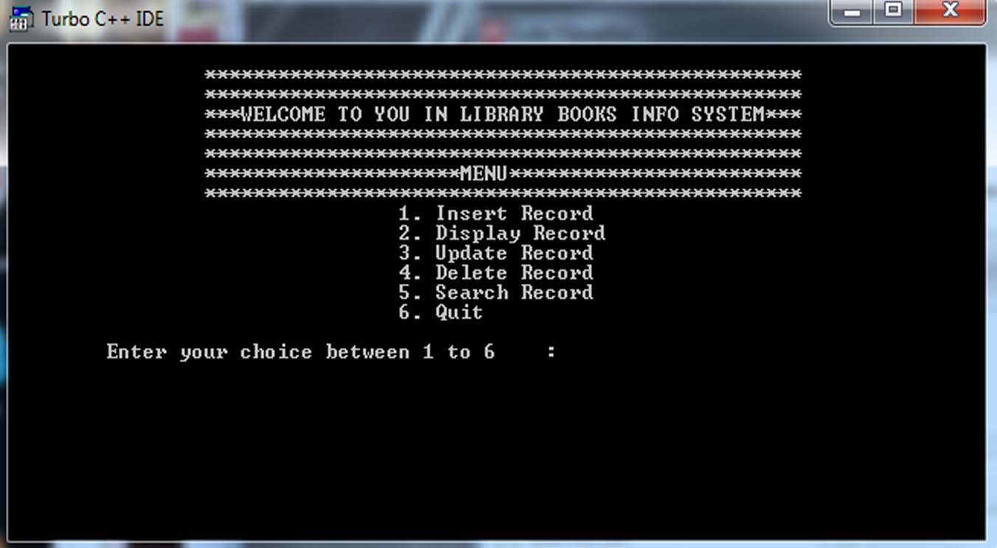

Similarly the user is provided the following menu options in order to search the required book in the program.

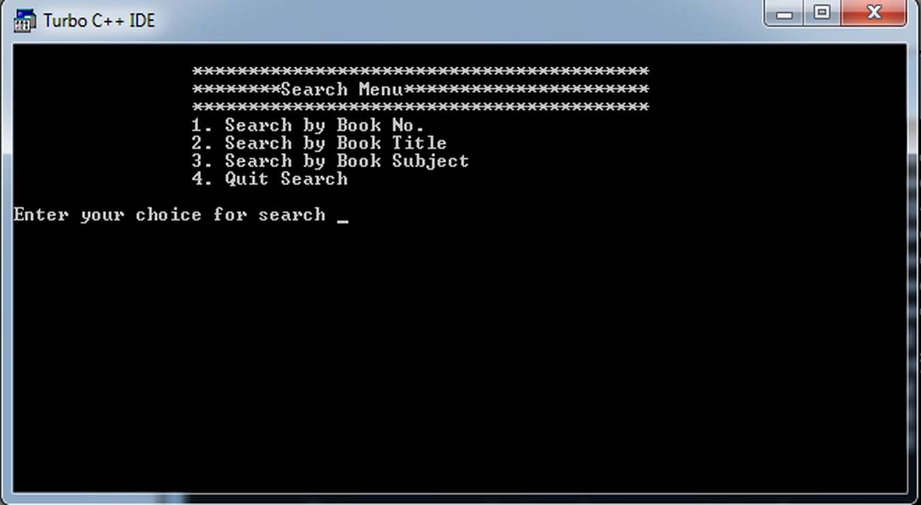

The input screen for inserting the record of new book in library is as follows:

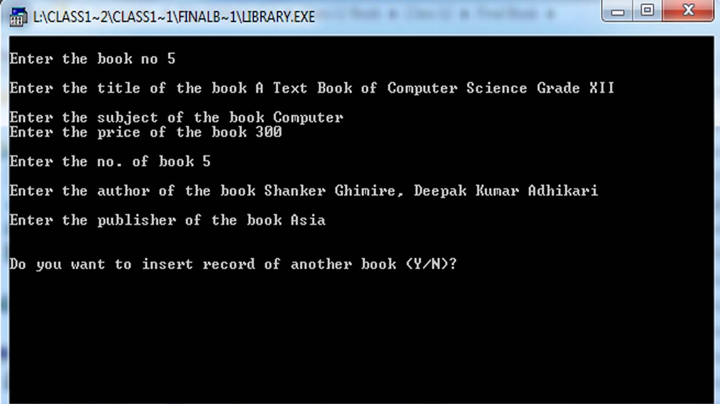

**Output Design:**

Output design deals with how the information or output of the program will be displayed on the screen or printed from the printer. The softcopy output of the project will be displayed only on the CUI environment.

The output of the display operations will be as follows:

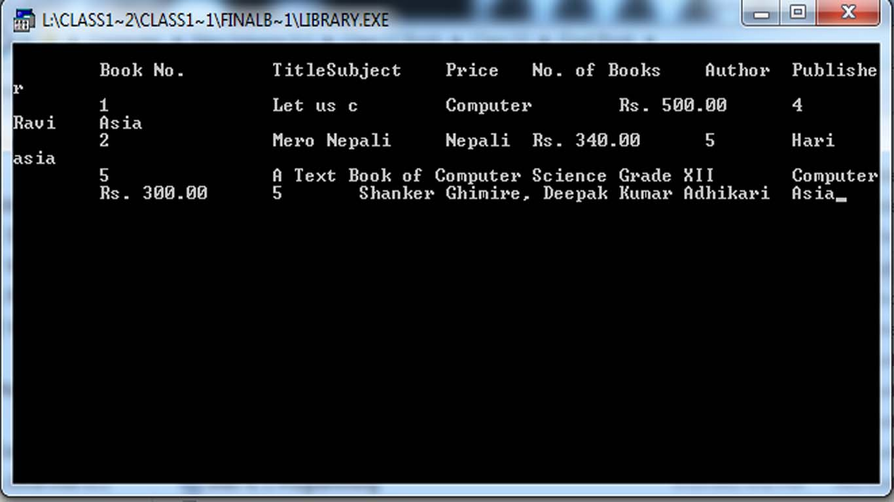

The output of the search operation will be displayed as follows:

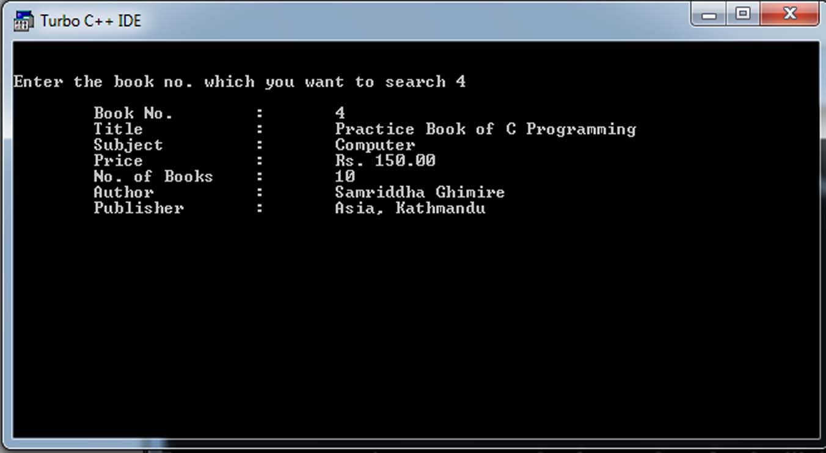

1. **Coding**

The entire coding of the project is done in Turbo C++ as the project is based on the C language. The entire coding has been already pasted in the above pages.

//code to include necessary header files

#include<stdio.h>

#include<conio.h>

#include<process.h>

#include<string.h>

//Code to declare function prototype

void insertData();

void displayData(void);

void updateData(int);

void deleteData(int);

void searchData(void);

int checkBookNo(int);

int findLastBookNo(void);

//code to declare file pointer

FILE *fp,*fp1;

//code to design structure

struct book

{

int bn;

char title[200];

char sub[100];

float price;

int nob;

char author[100];

char publisher[100];

};

//code to declare structure variable

struct book b;

//code to declare main function

main()

{

int choice;

int bn;

while(1)

{

//code to display menu

clrscr();

printf("\n\t\t*************************************************");

printf("\n\t\t*************************************************");

printf("\n\t\t***WELCOME TO YOU IN LIBRARY BOOKS INFO SYSTEM***");

printf("\n\t\t*************************************************");

printf("\n\t\t*************************************************");

printf("\n\t\t*********************MENU************************");

printf("\n\t\t*************************************************");

printf("\n\t\t\t\t1. Insert Record ");

printf("\n\t\t\t\t2. Display Record");

printf("\n\t\t\t\t3. Update Record");

printf("\n\t\t\t\t4. Delete Record");

printf("\n\t\t\t\t5. Search Record");

printf("\n\t\t\t\t6. Quit");

printf("\n\n\tEnter your choice between 1 to 6 : ");

scanf("%d",&choice);

switch (choice)

{

case 1:

//code to call insertData function

insertData();

break;

case 2:

//code to call displayData function

displayData();

break;

case 3:

//code to call updateData function

printf("\n Enter the book no. which you want to update ");

scanf("%d",&bn);

updateData(bn);

break;

case 4:

//code to call deleteData function

printf("\n Enter the book no. which you want to delete ");

scanf("%d",&bn);

deleteData(bn);

break;

case 5:

//code to call searchdata function

searchData();

break;

case 6:

exit(0);

default:

printf("\n\a\aSORRY!!! You entered an invalid choice ");

printf("\n Please, enter the valid choice between 1 to 6 ");

getch();

}

}

}

//Code to declare function definition

void insertData()

{

char next='y';

int duplicatebookno=0,lastbookno;;

clrscr();

while(next=='y'||next=='Y')

{

aa:

clrscr();

printf("\nEnter the book no ");

scanf("%d",&b.bn);

//code to call function to check the book no. has been repeated or not

duplicatebookno=checkBookNo(b.bn);

if(duplicatebookno==1)

{

printf("\n\nThe book no. which you typed just now, is already exists in the data file!!!!!");

printf("\n\nPlease, enter the unique book no.!!!");

lastbookno=findLastBookNo();

printf("\n\nThe last book no. is : %d",lastbookno);

getch();

goto aa;

}

fflush(stdin);

printf("\nEnter the title of the book ");

gets(b.title);

printf("\nEnter the subject of the book ");

gets(b.sub);

printf("Enter the price of the book ");

scanf("%f",&b.price);

printf("\nEnter the no. of book ");

scanf("%d",&b.nob);

fflush(stdin);

printf("\nEnter the author of the book ");

gets(b.author);

printf("\nEnter the publisher of the book ");

gets(b.publisher);

fp=fopen("Book.dat","a");

if(fp==NULL)

{

printf("\nFile creation error has occurred!!!");

}

else

{

fwrite(&b,sizeof(b),1,fp);

fclose(fp);

printf("\n\nDo you want to insert record of another book (Y/N)? ");

next=getche();

}

}

}

void displayData(void)

{

clrscr();

fp=fopen("Book.dat","r");

rewind(fp);

if(fp==NULL)

{

printf("\n\nRead operation failure as the file file which you are searching does not exist!!!");

}

else

{

printf("\n\tBook No.\tTitle\Subject\tPrice\tNo. of Books\tAuthor\tPublisher");

while(fread(&b,sizeof(b),1,fp)==1)

{

printf("\n\t%-8d\t%s\t%s\tRs. %.2f\t%d\t%s\t%s",b.bn,b.title,b.sub,b.price,b.nob,b.author,b.publisher);

}

fclose(fp);

}

getch();

}

void updateData(int bn)

{

fp=fopen("Book.dat","r");

fp1=fopen("newBook.dat","w");

if(fp==NULL || fp1==NULL)

{

printf("\nFile Operation failed");

}

else

{

//code to show the existing data

printf("\n\nThe followings are the existing data!!!!!!");

while(fread(&b,sizeof(b),1,fp)==1)

{

if(b.bn==bn)

{

printf("\n\tBook No. : %d",b.bn);

printf("\n\tTitle : %s",b.title);

printf("\n\tSubject : %s",b.sub);

printf("\n\tPrice : Rs. %.2f",b.price);

printf("\n\tNo. of Books : %d",b.nob);

printf("\n\tAuthor : %s",b.author);

printf("\n\tPublisher : %s",b.publisher);

}

}

//code to enter new data

rewind(fp);

printf("\n\nEnter the new correct data ");

while(fread(&b,sizeof(b),1,fp)==1)

{

if(bn==b.bn)

{

printf("\n\n\nEnter the book no ");

scanf("%d",&b.bn);

fflush(stdin);

printf("\nEnter the title of the book ");

gets(b.title);

printf("\nEnter the subject of the book ");

gets(b.sub);

printf("Enter the price of the book ");

scanf("%f",&b.price);

printf("\nEnter the no. of book ");

scanf("%d",&b.nob);

fflush(stdin);

printf("\nEnter the author of the book ");

gets(b.author);

printf("\nEnter the publisher of the book ");

gets(b.publisher);

fwrite(&b,sizeof(b),1,fp1);

}

else

{

fwrite(&b,sizeof(b),1,fp1);

}

}

fclose(fp);

fclose(fp1);

remove("Book.dat");

rename("newBook.dat","Book.dat");

printf("\n\nThe record has been successfully updated in the data file");

}

getch();

}

void deleteData(int bn)

{

fp=fopen("Book.dat","r");

fp1=fopen("newBook.dat","w");

if(fp==NULL || fp1==NULL)

{

printf("\nFile Operation failed");

}

else

{

while(fread(&b,sizeof(b),1,fp)==1)

{

if(bn==b.bn)

{

continue;

}

else

{

fwrite(&b,sizeof(b),1,fp1);

}

}

fclose(fp);

fclose(fp1);

remove("Book.dat");

rename("newBook.dat","Book.dat");

printf("\n\nThe record has been successfully deleted from the data file");

}

getch();

}

void searchData(void)

{

int bn,found=0;

char bname[100],subject[100];

int ch;

clrscr();

printf("\n\t\t*****************************************");

printf("\n\t\t********Search Menu**********************");

printf("\n\t\t*****************************************");

printf("\n\t\t1. Search by Book No. ");

printf("\n\t\t2. Search by Book Title ");

printf("\n\t\t3. Search by Book Subject ");

printf("\n\t\t4. Quit Search");

printf("\n\nEnter your choice for search ");

scanf("%d",&ch);

switch(ch)

{

case 1:

//search on the basis of book no.

clrscr();

fp=fopen("Book.dat","r");

printf("\n\nEnter the book no. which you want to search ");

scanf("%d",&bn);

if(fp==NULL)

{

printf("\nFile search operation failed!!!!!!!!!!!!!!!!");

}

else

{

while(fread(&b,sizeof(b),1,fp)==1)

{

if(b.bn==bn)

{

printf("\n\tBook No. : %d",b.bn);

printf("\n\tTitle : %s",b.title);

printf("\n\tSubject : %s",b.sub);

printf("\n\tPrice : Rs. %.2f",b.price);

printf("\n\tNo. of Books : %d",b.nob);

printf("\n\tAuthor : %s",b.author);

printf("\n\tPublisher : %s",b.publisher);

found=1;

}

}

if(found==0)

{

printf("\n!!!!!!!!!!!!!!!!!!!!!!!!!!!!!!!!!!!!!!");

printf("\nThe book which you are searching is not found ");

}

fclose(fp);

}

break;

case 2:

//searh on the basis of book title

clrscr();

fflush(stdin);

printf("\n\nEnter the title of the book which you want to search ");

gets(bname);

fp=fopen("Book.dat","r");

if(fp==NULL)

{

printf("\nFile search operation failed!!!!!!!!!!!!!!!!");

}

else

{

while(fread(&b,sizeof(b),1,fp)==1)

{

if(strcmpi(b.title,bname)==0)

{

printf("\n\tBook No. : %d",b.bn);

printf("\n\tTitle : %s",b.title);

printf("\n\tSubject : %s",b.sub);

printf("\n\tPrice : Rs.%.2f",b.price);

printf("\n\tNo. of Books : %d",b.nob);

printf("\n\tAuthor : %s",b.author);

printf("\n\tPublisher : %s",b.publisher);

found=1;

}

}

if(found==0)

{

printf("\n!!!!!!!!!!!!!!!!!!!!!!!!!!!!!!!!!!!!!!");

printf("\nThe book which you are searching is not found ");

}

fclose(fp);

}

break;

case 3:

//search on the basis of subject

clrscr();

fflush(stdin);

printf("\n\nEnter the subject of the book which you want to search ");

gets(subject);

fp=fopen("Book.dat","r");

if(fp==NULL)

{

printf("\nFile search operation failed!!!!!!!!!!!!!!!!");

}

else

{

while(fread(&b,sizeof(b),1,fp)==1)

{

if(strcmpi(b.sub,subject)==0)

{

printf("\n\tBook No. : %d",b.bn);

printf("\n\tTitle : %s",b.title);

printf("\n\tSubject : %s",b.sub);

printf("\n\tPrice : Rs.%.2f",b.price);

printf("\n\tNo. of Books : %d",b.nob);

printf("\n\tAuthor : %s",b.author);

printf("\n\tPublisher : %s",b.publisher);

found=1;

}

}

if(found==0)

{

printf("\n!!!!!!!!!!!!!!!!!!!!!!!!!!!!!!!!!!!!!!");

printf("\nThe book which you are searching is not found ");

}

fclose(fp);

}

break;

case 4:

//code to close search window

printf("\nPress any key to quit the search operation");

break;

default:

printf("\nYou entered invalid choice for search ");

}

getch();

}

int checkBookNo(int bn)

{

int repeated=0,lastbookno;

struct book b1;

fp=fopen("Book.dat","r");

if(fp==NULL)

{

printf("\n\nRead operation failure as the file file which you are searching does not exist!!!");

}

else

{

while(fread(&b1,sizeof(b1),1,fp)==1)

{

if(b1.bn==bn)

{

repeated=1;

break;

}

}

fclose(fp);

}

return(repeated);

}

int findLastBookNo()

{

int lastbookno;

struct book b2;

fp=fopen("Book.dat","r");

if(fp==NULL)

{

printf("\n\nFile open operation failure!!!");

}

else

{

while(fread(&b2,sizeof(b2),1,fp)==1)

{

lastbookno=b2.bn;

}

fclose(fp);

}

return(lastbookno);

}

1. **Testing**

Testing in a project development is a very important task to find out the possible mistakes made by the developers. The system cannot give the correct output until the project contains no errors at all. This project has checked the possible errors by using the following approaches:

* 1. Black Box Testing Approach: This approach concentrates on the basic requirements of the project. It simply checks whether the project can be run without detail description of internal coding. It checks direct matching of records of particular book, after we select a book no of a particular student.
  2. White Box Testing Approach: This approach concentrates on the actual codes written during the development of the project. It checks every lines of codes in all the functions of the program.

This project has fully tested by using both approaches and ensures the correct output.

1. **Implementation**

It is the process of using the project in client’s computer. After the executive file has been created, this project can be copied from saved source to any secondary storage device and pasted to the required system. The project can be operated by opening it, completely replacing the existing manual system.

1. **Maintenance**

When time changes, the requirements of the organization also changes and this project can no longer fulfill its requirements. The changes are necessary to keep the project running and useful to college. Maintenance may be required when the college changes its requirements.